Oil in Water test Strips

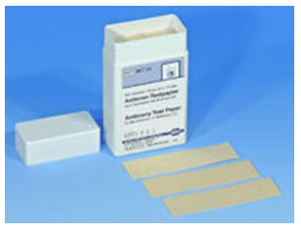

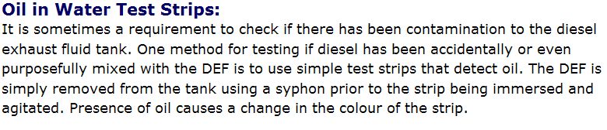
Part number 44-863
For enquiries in North America contact:
sales.bs.us@xyleminc.com
Bellingham + Stanley Inc.
1000 Hurricane Shoals Road
Building D, Suite 300
Lawrenceville, GA 30043
USA
Tel: | 770 822 6898
Fax: | 770 822 9165
Toll free (USA only): | 800 678 8573

